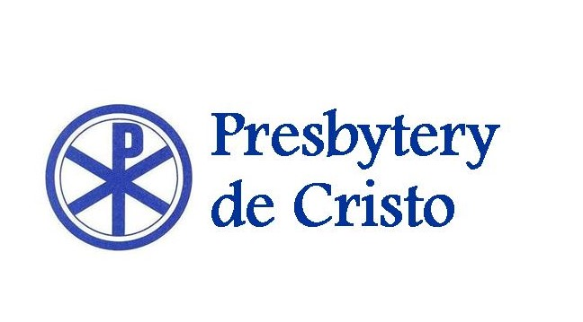
Serving Christ, Serving Congregations, Caring for “the least of these”
September 2022

To: Sessions, Mission Committees, Finance Committees, and the Teaching Elders with whom they serve
From: Mission Committee

Greetings in the name of the Lord Jesus! It is our prayer and hope that your congregation is growing in relationship with the 8 Mission Partners supported by Presbytery de Cristo.: Compañeros en Misión, Frontera de Cristo, Korean Presbyterian Church, Middle Eastern Presbyterian Fellowship, Montlure Presbyterian Camp, Papago United Presbyterian Church, Presbyterian Campus Ministry, and Tucson Borderlands Young Adult Volunteers. You have all been generous in the past and for this the Mission Committee and our 8 mission partners thank you.

Las Noticias, the weekly e-newsletter of Presbytery de Cristo, is the prime communication tool that connects our congregations in mission throughout the Presbytery. Our Mission partners highlight their ministries, make prayer requests, post pictures, extend invitations to visit, promote their special events, and describe their needs. Please make sure that your Session and Mission Committee are all subscribed to Las Noticias by contacting Sue Houser at the Presbytery office (pbyoffice@gmail.com) or via www.azpresbyteries.org.

It’s Now Time to Pray, Pledge and Give! We invite you and your Session to prayerfully consider how you will support these missions, who are our partners, our brothers, and sisters in Jesus, and who serve God on behalf of all of us. The PCUSA is a connectional church, and the enclosed mission pledge form is a way to give tangible expression to our covenantal connections in Christ Jesus! Please mail or email the pledge form on the next page to the Presbytery office by December 1, 2022 You will note that only your Presbytery pledge is needed on this year’s form.

Mail to: Presbytery de Cristo Email to: pbyoffice@gmail.com
4141 E. Thomas Road
Phoenix, AZ 85018

Church Treasurers should send Synod and PC(USA) and General Assembly Mission pledge monies directly to those offices:

Synod of the Southwest Presbyterian Church USA
5901 W. Wyoming NE #J-319 P.O. Box 643700
Albuquerque, NM 87109 Pittsburgh, PA 15264-3700

Mission Committee members: Ruth Van Otten, Moderator; the Rev. Brad Munroe, Presbytery Pastor; Bonnie Thompson, Secretary; Robb Victor, Treena Parvel, Billie Holbrook, the Rev. ; CRE Larry Biehl, CRE Josefina Ahumada; Peter Holbrook; Vicky Johnson; Robert Victor.

2023 MISSION GIVING PLEDGE
Our Church’s Support for our Shared Mission

CHURCH _____________________________________________________ PIN NO.__________
ADDRESS ______________________________________________________________________
CITY __________________________________________ STATE _____ ZIP _______________
PHONE ___________________________ EMAIL ____________________________________
Mission committee chairperson and contact information:
________________________________________________________________________________
We pledge to support Presbytery de Cristo’s mission partners in 2023.

Presbytery de Cristo Mission Pledge $_____________
(Administered by PDC Mission Committee)

Please send completed form by December 1, 2022 to:
Presbytery de Cristo
ATTN: Mission Committee, Ruth Van Otten, Moderator
4141 E. Thomas Rd.
Phoenix, AZ 85018

Tel: 602-468-3820
Fax: 602-468-3824
You may also email this form to: pbyoffice@gmail.com

Signature (Pastor or Clerk of Session) ___________________________________________Date ____

